CASE customer M&J Evans Group chooses CASE excavators for safety, reliability, and operator productivity
Turin, 14 December 2021
M&J Evans Group (M&J Evans), a customer of CASE Construction Equipment and dealer Warwick Ward, has acquired 20 CASE excavators equipped with 360-degree cameras and SiteWatchTM telematics, continuing the company’s CASE machine acquisition programme. Machine availability, alongside an interest in assessing reliability, operator comfort, fuel savings and total cost of ownership, are behind the investment in CASE equipment by one of the UK’s fastest-growing civil engineering contractors.
According to M&J Evans’ Plant and Transport Manager Philip McEvilly, the company’s growth, and expansion into Yorkshire, has fuelled demand for new equipment: “We’re active on nearly 200 sites across the UK, have expanded our base into a regional office to support our customers in Yorkshire, and recently acquired Swindon-headquartered Flynn Group, developing our footprint in the South West.”
McEvilly oversees the plant and transport division for the entire group country-wide with a team of more than 50 colleagues, who day-to-day manage over 4,000 pieces of equipment, ranging from small tools, lifting equipment and vans and cars, through HGVs, dumpers, rollers, dump trucks, dozers, and excavators.
“Sourcing new equipment in the current supply situation is challenging, but CASE supplied the 11 CX-210’s and 9 CX-130’s, to specification and within our timeframe. Safety is our priority, which is why the 360-degree cameras was an essential part of the specification. SiteWatchTM telematics will provide valuable cost and productivity data, enabling us to monitor and evaluate fuel savings and the resulting TCO improvements. The added benefit was working with the team at Warwick Ward’s Barnsley office, which is located close to our expanding office in nearby Sheffield.”
With its roots in the West Midlands town Brownhills, M&J Evans now focuses on delivering civil engineering, groundworks, and external works for most of the major housebuilders and developers throughout the UK. Already established in the North West (Warrington office) and the Midlands, with its group plant office in Walsall, the business is expanding into Yorkshire and the South West (Flynn’s Groups Swindon and Bristol offices).
Warwick Ward’s Area Sales Executive for the Midlands Region, Martin Brain, takes up the story: “The CASE excavators built in Japan have been long recognised as a market leader in their field. We were able to demonstrate both the CX130D and CX210D models extensively to M&J Evans. Following excellent feedback from all the operators regards machine power, precision, and ease of control with a state-of-the-art cab and excellent fuel economy we were able to secure the deal.”
CASE Construction Equipment Business Director Northern Europe, Joseph O’Grady, is delighted that M&J Evans chose the CASE solution and become part of the CASE family: “I’m confident the performance, comfort and reliability of CASE excavators will support M&J Evans’ ongoing growth and expansion.”
McEvilly concludes: “To support our growth, we need equipment that’s fit-for-purpose in every respect, so will be reviewing reliability, operator comfort, fuel savings and total cost of ownership of our new CASE excavator fleet over the coming months. The good news is that we’ve already had great feedback from our operators.”
Ends
Notes to editors:
Please visit our website to download high-resolution text, video and image files (JPG 300 DPI, CMYK) and other CASE press releases: www.casecetools.com/press-kit

Captions for the people pictures can be found below.

Follow CASE on:

CASE Construction Equipment sells and supports a full line of construction equipment around the world, including the No. 1 loader/backhoes, excavators, motor graders, wheel loaders, vibratory compaction rollers, crawler dozers, skid steers, compact track loaders and rough-terrain forklifts. Through CASE dealers, customers have access to a true professional partner with world-class equipment and aftermarket support, industry-leading warranties and flexible financing. More information is available at www.CASEce.com.
CASE Construction Equipment is a brand of CNH Industrial N.V., a World leader in Capital Goods listed on the New York Stock Exchange (NYSE: CNHI) and on the Mercato Telematico Azionario of the Borsa Italiana (MI: CNHI). More information about CNH Industrial can be found online at www.cnhindustrial.com.
For more information contact:
Mike Doggwiler – Copestone on behalf of CASE Construction Equipment
+44 (0) 7802 196766
mike@copestone.uk.com

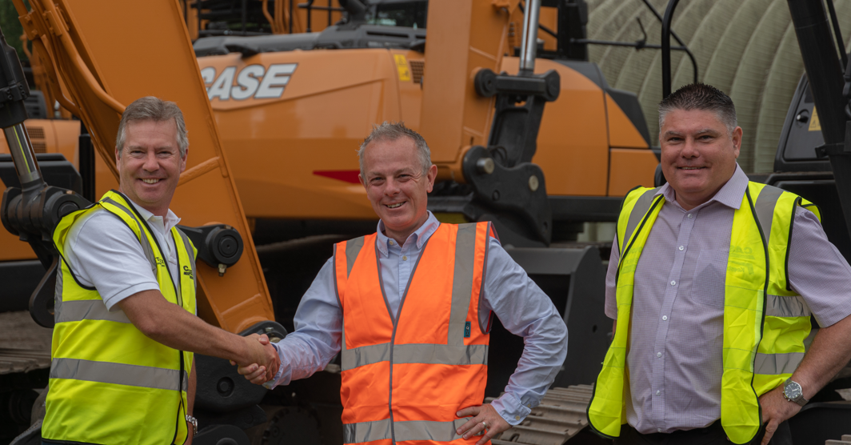
Ashley Ward (Joint Managing Director Warwick Ward), David Witney (Managing Director Yorkshire, M&J Evans), Philip McEvilly (Plant & Transport Manager At M&J Evans Construction)

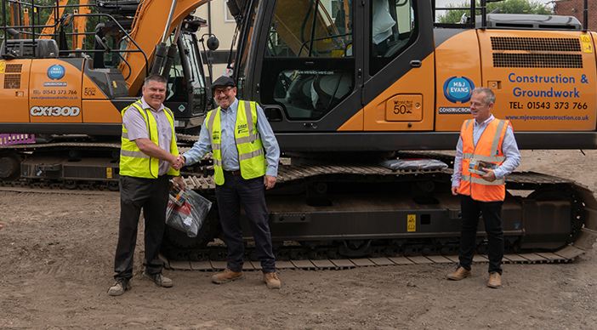
Philip McEvilly (Plant & Transport Manager At M&J Evans Construction), Martin Brain (Area Sales Case, Warwick Ward), David Witney (Managing Director Yorkshire, M&J Evans)

