Machines for demanding jobsites:
CASE crawler excavators at work throughout Europe

Turin, 11 January 2021

CASE Construction Equipment’s crawler excavators have recently been deployed across a diverse and challenging range of applications throughout Europe. The machines have been praised for their adaptability, efficiency, power and comfort, crucial factors in the kind of jobsites where the crawler excavator machines are at work.

As Giuseppe Santo, Crawler and Midi Excavator Product Manager, CASE Construction Equipment Europe, explains “the CASE crawler excavator range is designed to meet the demands of any jobsite. The machine’s features are geared towards versatility, power and unique precision, which explains why we are seeing them being used in a huge range of applications throughout Europe, delighting customers in the process.”

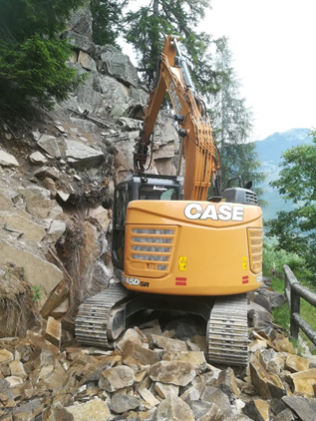
Compact build for tough mountain roads
The compact build of the CASE crawler excavator machines mean they are ideal for operating in limited space. A CX145D SR is one of a handful of machines on the market where the cabin can complete a full rotation with minimal risk of coming in to contact with the job environment.
For this reason, Italian company Bancoline (who specialises in road maintenance, demolition and building,) chose to use the machine to maintain a series of mountain roads. “Our operator loves the machine,” said Mauro Goss the owner from Bancoline.
“Working on these tightly packed mountain roads at altitude means a machine with CX145D SR’s manoeuvrability is essential and a great time saver.”

Power and precision after a natural disaster
When a storm hit North East Italy in October 2018, thousands of acres of forest was destroyed overnight. Moena, located in Trento, not far from the devastation, was tasked with the clean-up operation, purchasing a CASE CX245D SR equipped with a unique “harvester” attachment to do so.
“We were already impressed with the CX145D SR but needed something slightly more powerful for the job at hand,” said Turri Michele the owner, from Malé in Val di Sole. “The CX245D SR delivered this in abundance. Its tracking force meant we were able to quickly remove all the damaged trees with ease, and with the telematics solution fitted the harvester attachment also allowed us to keep track of the length and diameter of each tree cut.”

Spanish based Maderas Marcos also operates in the forestry sector, this time using a CASE CX210D. CASE dealer Ruvisca fitted the machine with a forestry harvester, used to process pine and eucalyptus wood.

“The power and the precision of the CX210D has been perfect for this application. Overall, we are very happy with the machine. Our relationship with the dealer has grown and through that, we know that we’re buying equipment that is reliable and helps us with our main customer ENCE, which is a leading Spanish producer of eucalyptus pulp and biomass renewable energy. They use plant residue and waste to create clean energy as well as maintaining unkept trees in order to prevent pollution and to avoid accidental fires.” said Rodolfo, the owner.

Exceptional fuel efficiency during ground clearing
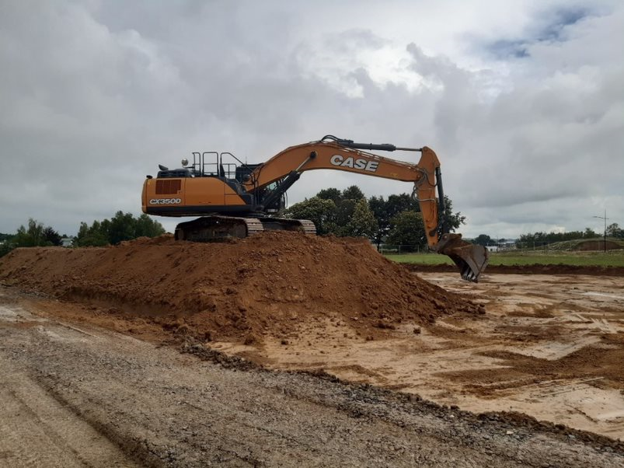
France’s Potin TP, a CASE customer for over 18 years, operates a fleet of 20 CASE machines, of which one is a CX350D. This was recently at work digging the foundations for a new office block and green space. While doing so, it was able to save five litres per hour of fuel, as Thomas Cochet, Potin TP’s operator with 14 years of experience in crawler excavators, explains: "I like the Series because it's easier to access for maintenance and everything is close at hand. The low fuel consumption and thus reduced CO2 emissions are an amazing surprise which is not only good for the environment but results in cost savings.”

Demolition at any height
Demolition of tall buildings with traditional excavators can often present issues. Fitting the machine with a 21-metre-long extended arm is one way to tackle this, as German-based Paul Kamrath Ingenieurrückbau GmbH recently demonstrated with a CX350D.
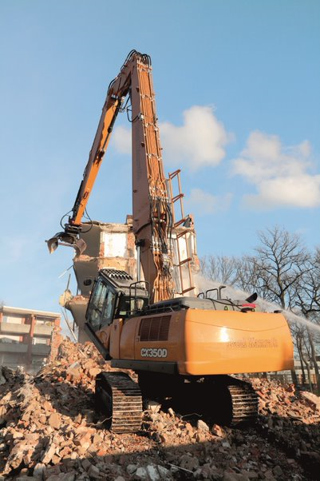
Sebastian Morsmann , the operator said: "The CASE CX350D can be controlled safely and precisely. The attachment reacts very directly to every control movement and I have good feedback from the joysticks.
When working with long equipment, the tilting cabin is a major help as you always have a clear view of the tool and the CASE maximum view monitor, with its bird’s eye and panoramic view improves safety a lot.
Compared to other machines, the cabin is more spacious and better equipped”, points out Sebastian.

Demolition is also the focus for Italian company P.R.A, which operate a CASE CX370D with a two-piece boom. “The CASE CX370 two-piece boom was what we needed. The manoeuvrability, hydraulics, and consumption are all exceptional and ideal for the jobsites we work on. In addition, the boom and arm are robust, and the undercarriage is easy to clean. That’s why I strongly recommended CASE!” said Matthias, the P.R.A operator.

The future of the CASE Crawler excavators
“We are proud that customers who work in challenging and demanding fields choose CASE for their unique jobsites. "This is why CASE as a manufacturer always strives to be attentive, whilst capturing market trends and continuously seeking to innovate and provide machines that directly deal with operators’ needs,” continues Santo.

“On one hand, we have the responsibility to not change what makes CASE excavator’s unique – its outstanding operator comfort which, can satisfy the most demanding operators. Its best balance between speed and controllability with an unpaired fuel and energy saving – and on the other, the continuous improvement is part of our daily work and this is what we are doing.

“Despite COVID-19, we have stayed focussed and are preparing for our next generation of machines by taking proper consideration of the growing needs for versatility and leveraging partnerships with CNH Industrial brands. All machines will be made in Japan and will include the 20 and 24-tonne narrow undercarriage mono and two- piece boom. “We know more key trends have emerged over the last few years and we will continue listening to our customers and investing in new developments. These are the essential elements that underpin our ability to move forward and prosper together. We have the resources and competencies to ensure that we take all the steps required to do so,” he concluded.

END COPY
Notes to editors:
Please visit our website to download high-resolution text, video and image files (JPG 300 DPI, CMYK) and other CASE press releases: www.casecetools.com/press-kit

Follow CASE on:

CASE Construction Equipment sells and supports a full line of construction equipment around the world, including the No. 1 loader/backhoes, excavators, motor graders, wheel loaders, vibratory compaction rollers, crawler dozers, skid steers, compact track loaders and rough-terrain forklifts. Through CASE dealers, customers have access to a true professional partner with world-class equipment and aftermarket support, industry-leading warranties and flexible financing. More information is available at www.CASEce.com.
CASE Construction Equipment is a brand of CNH Industrial N.V., a World leader in Capital Goods listed on the New York Stock Exchange (NYSE: CNHI) and on the Mercato Telematico Azionario of the Borsa Italiana (MI: CNHI). More information about CNH Industrial can be found online at www.cnhindustrial.com.
For more information contact:
Rakhee Rathod – Copestone on behalf of CASE Construction Equipment
+44 (0) 7944 853985
rakhee@copestone.uk.com

